Section 1. Header

<https://preview.themeforest.net/item/invent-education-course-college-wordpress-theme/full_screen_preview/9263796?clickid=UNWSAdTAUxyIUtg2PrSWkwB7UkDxBJQoZQdpV40&iradid=275988&iradtype=ONLINE_TRACKING_LINK&irgwc=1&irmptype=mediapartner&irpid=369282&mp_value1=&utm_campaign=af_impact_radius_369282&utm_medium=affiliate&utm_source=impact_radius>

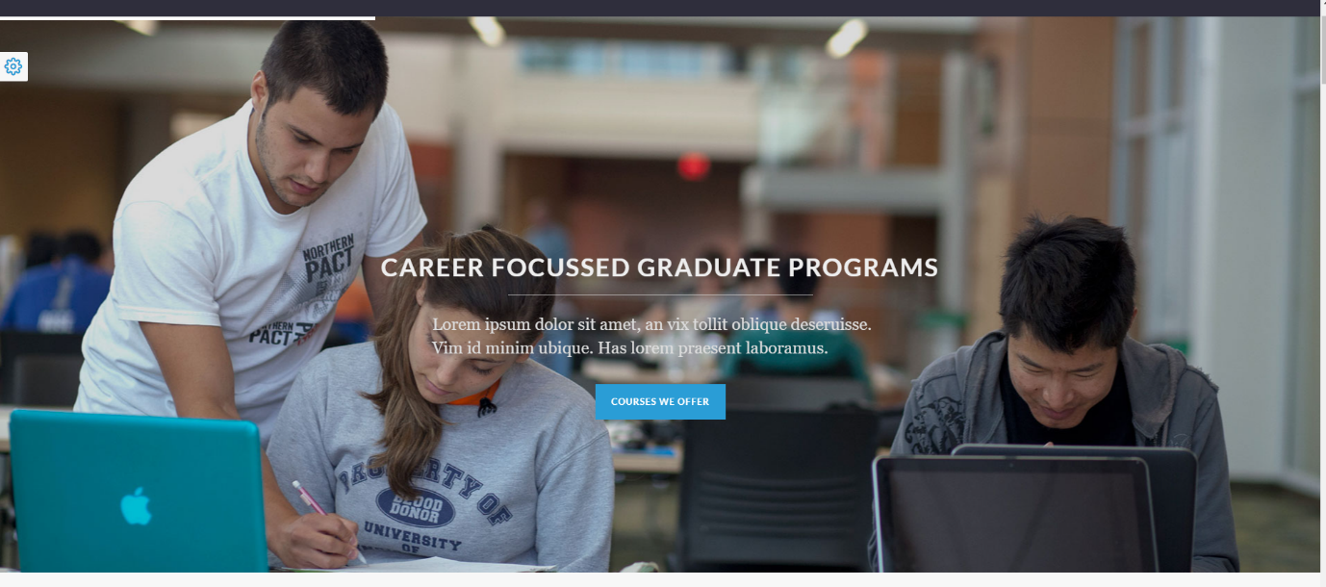

Section 2. Leadform

Section 3. About Way2overseas

<https://keenitsolutions.com/products/wordpress/educavo/home-5/>



Section 4. Popular Courses

<https://preview.themeforest.net/item/education-center-training-courses-wordpress-theme/full_screen_preview/10652918?_ga=2.42606567.319372250.1653622036-1232652046.1643700412>



Section 5. Why Philippines

<http://preview.themeforest.net/item/manzil-construction-and-building-wordpress-theme/full_screen_preview/28192489?_ga=2.82984916.319372250.1653622036-1232652046.1643700412>



Section 6. Featured Colleges

Section 7. Enrollment Process

<http://preview.themeforest.net/item/enfant-school-and-kindergarten-wordpress-theme/full_screen_preview/20121401?clickid=UNWSAdTAUxyIUtg2PrSWkwB7UkDxBJyMZQdpV40&iradid=275988&iradtype=ONLINE_TRACKING_LINK&irgwc=1&irmptype=mediapartner&irpid=369282&mp_value1=&utm_campaign=af_impact_radius_369282&utm_medium=affiliate&utm_source=impact_radius>

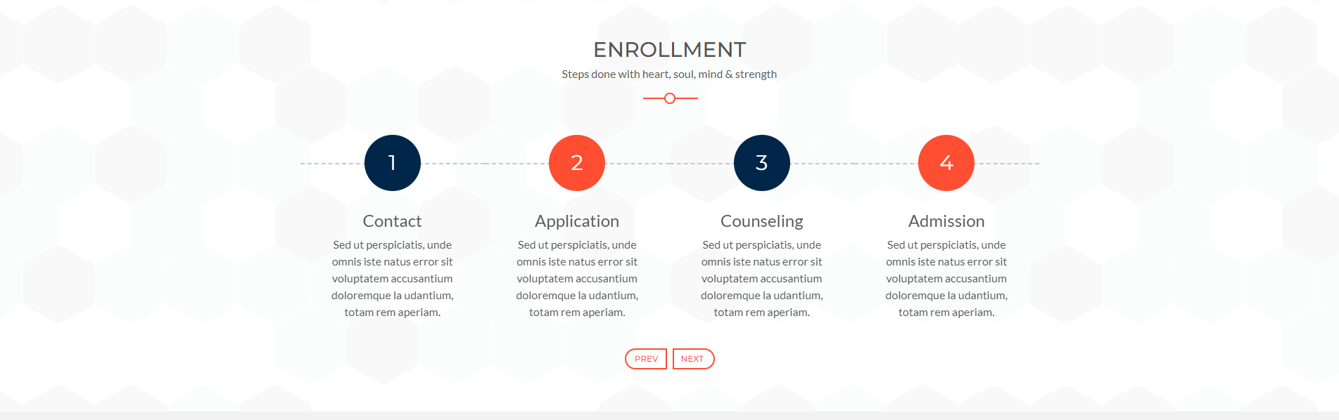

Section 8. Video Gallery

Section 9. Footer

<http://preview.themeforest.net/item/manzil-construction-and-building-wordpress-theme/full_screen_preview/28192489?_ga=2.82984916.319372250.1653622036-1232652046.1643700412>

